The Crucible: Who is to Blame?
Who can be held most responsible for the injustice that occurred in Salem? Select one character from the play and argue why this character holds the most blame and what larger point Arthur Miller was trying to say about injustice through this character.

Directions:
- Select one character from the play who you think is the most responsible for the events in Salem in 1692. You may wish to consider: Danforth, Abigail, Proctor, Parris, Tituba, or Thomas Putnam.
- Identify three character flaws each character possesses that would cause them to act the way they did, thus wrecking havoc in Salem.
- Write a solid introduction, with a thesis statement, that specifies: the character that holds the most blame for the injustice in Salem and what Miller was trying to say about injustice through this theme or character.
- Find specific evidence to support your argument from the text.
- Write a solid conclusion that reinforces why you selected the character or theme you did and the reasons why that person is the most blameworthy.

The Specifics:
- Your essay must be typed, double spaced. It should be at least three full pages in length.
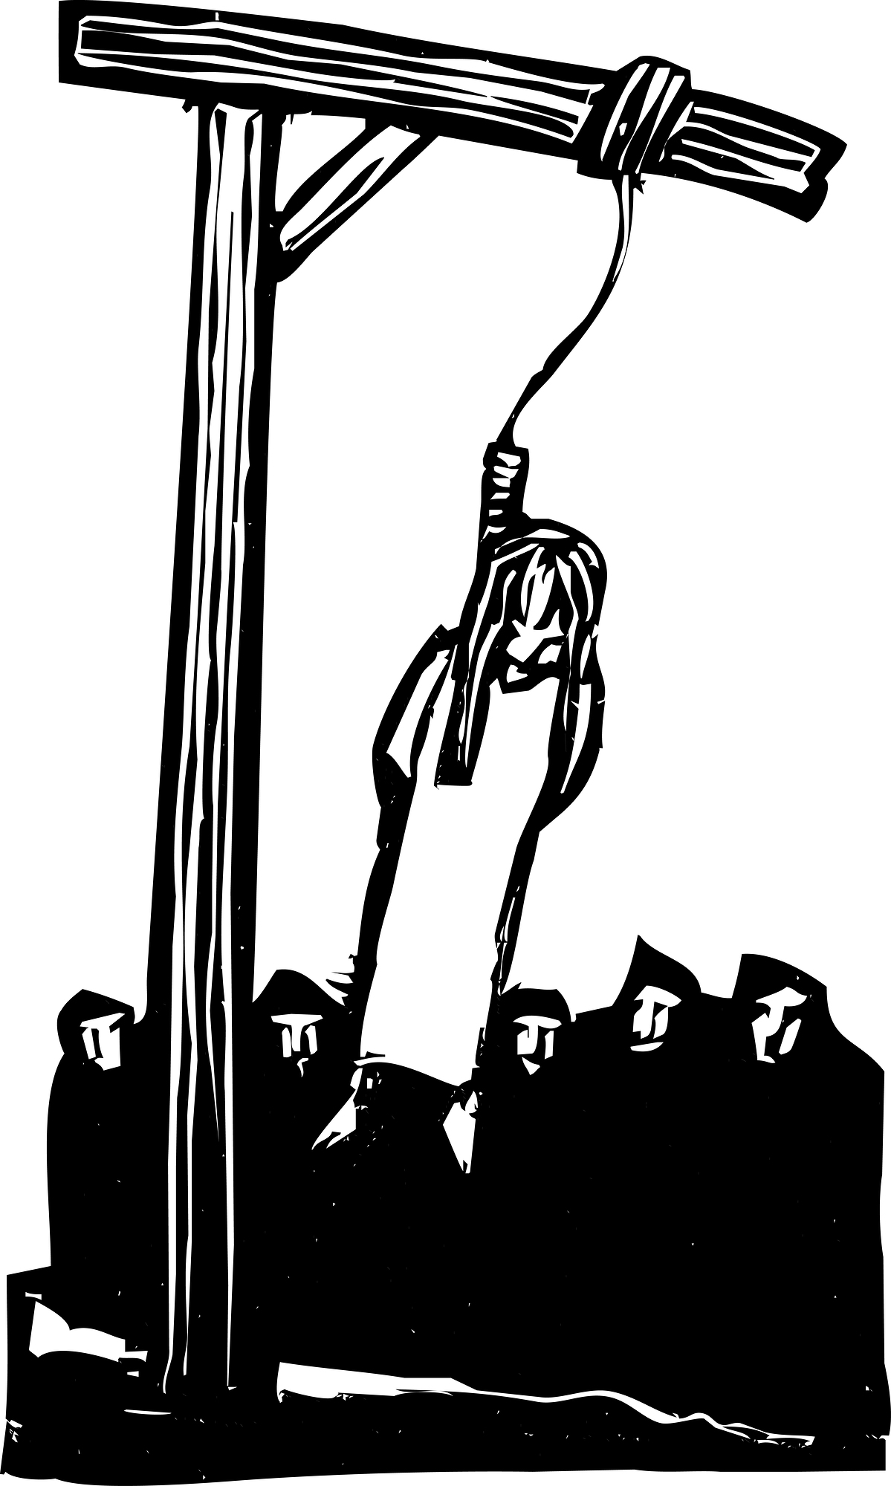
- Use only a 12-point font (Times New Roman or Georgia) and 1-inch margins. Points will be deducted for adding extra margin spaces or using a larger font.
- Your essay is to be typed, printed, and ready to go at the beginning of class on the due date.
- The essay is worth 100 points, and will be graded according to the attached rubric.
- You are not to use any sources for this essay other than your Crucible book.
- For the record, I consider five words verbatim from another source to be considered plagiarism. Do not copy someone else’s work.
- Papers with more than five blatant grammatical errors will not be graded until fixed. If they are not fixed, they will earn a zero. Blatant errors include: spelling, capitalization, punctuation (no periods, apostrophe usage), and subject verb agreement (we’ve practiced this together in class!).

Who is to Blame?: Essay Planner
Character/selected: ___________________________

Three character flaws:

__________________ __________________ __________________

How does character show Flaw #1:

Quote from text that shows flaw #1 | Analysis of quote (2-3 sentences)

Quote from text that shows flaw #1 | Analysis of quote (2-3 sentences)

How does character show Flaw #2:

Quote from text that shows flaw #2 | Analysis of quote (2-3 sentences)
Quote from text that shows flaw #2 | Analysis of quote (2-3 sentences)

How does character show Flaw #3:
Quote from text that shows flaw #3 | Analysis of quote (2-3 sentences)
Quote from text that shows flaw #3 | Analysis of quote (2-3 sentences)

The Crucible Character Flaws
Flaw | Description of Flaw
Lust | Driven by desire; preoccupied with or exhibiting sexual desires.
Pride | Filled with or showing excessive self-esteem, and will often reject help from  others for the sake of pride.
Greed | Excessive or rapacious desire, especially for wealth or possessions.
Vengefulness | Revengeful; spiteful; desiring or seeking vengeance; vindictive
Ignorance | Lacking knowledge or information as to a particular subject or fact.
Jealousy | Showing extreme cupidity, painfully desirous of another’s advantages, covetous
Spitefulness | Showing malicious ill will and a desire to hurt; motivated by spite; vindictive person who will look for occasions for resentment.
Stubbornness | Unreasonably, often perversely unyielding; bullheaded. Firmly resolved or determined; resolute
Self-righteousness | Piously sure of one’s own righteousness; moralistic. Exhibiting pious self-assurance. Holier-than-thou, sanctimonious.
Remorselessness | Having no pity or compassion; without remorse; merciless; pitiless; relentless
Mendacity | The ability to be untruthful, the instance of lying and being false
Idealism | The pursuit of high or noble principals, purposes, and/or goals.
Hypocrisy | One who is always contradicting their own beliefs, actions, or sayings. A person who professes beliefs and opinions for others that he or she does not hold.
Arrogance | Having or displaying a sense of overbearing self-worth or self-importance. Inclined to social exclusiveness and who rebuff the advances of people considered inferior. Snobbish.

