Name: ________________________________
Graph of the Week
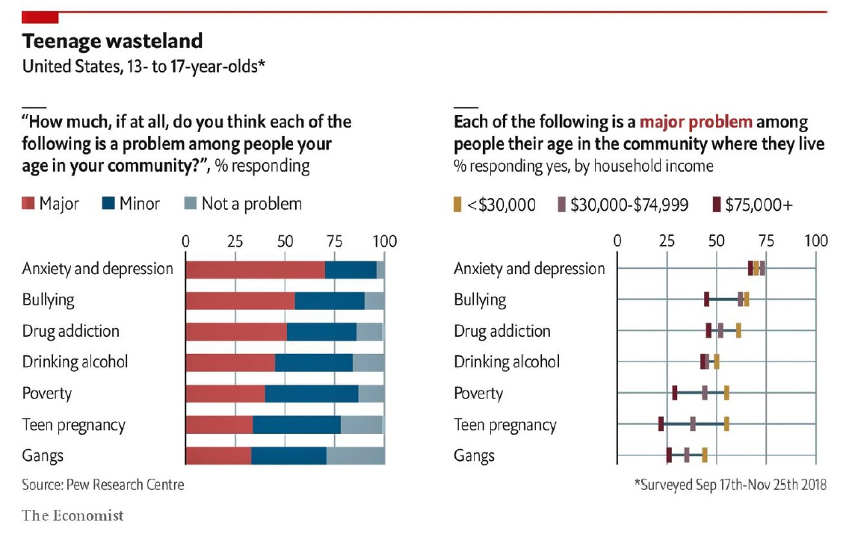
- What is the graph about?
- In the graph of the left, what quantities are being compared?
- What are some observations you can make based on these graphs?
- What do you think might happen in the next 10 years?

