Begin at the WCSKIDS.net
- Select the PARENTS/STUDENTS tab at the top.
- Select STUDENT EMAIL LOGIN.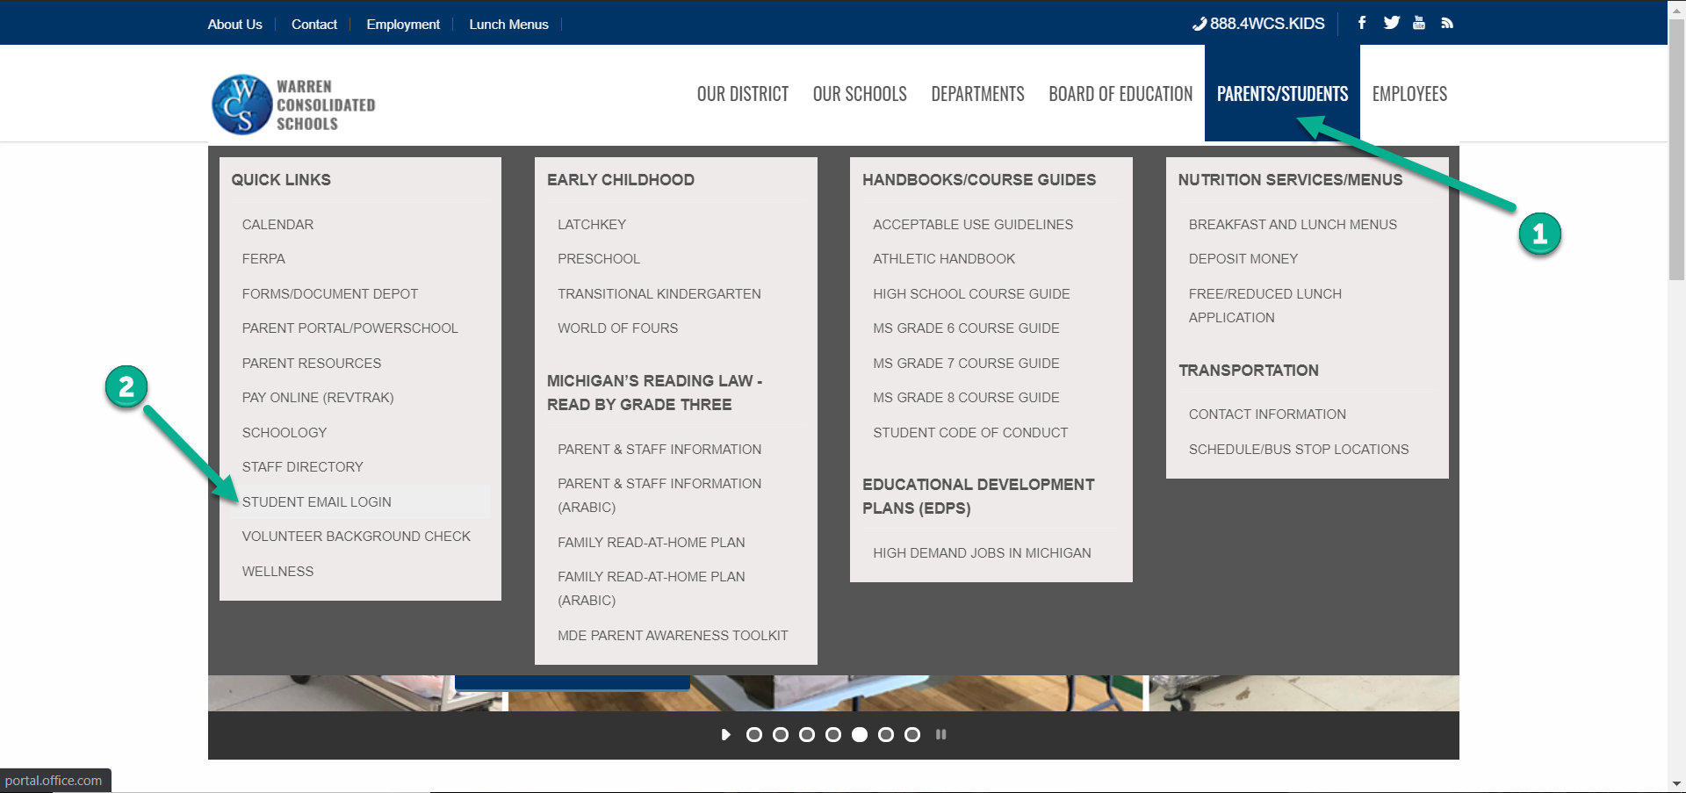

- Type in your student ID number followed by @wcskids.net (ex. 123456@wcskids.net).
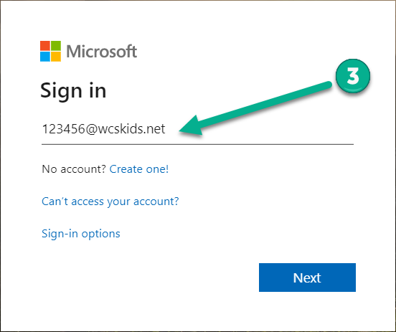.

- Enter your district-provided password in all CAPS (ex ABC123).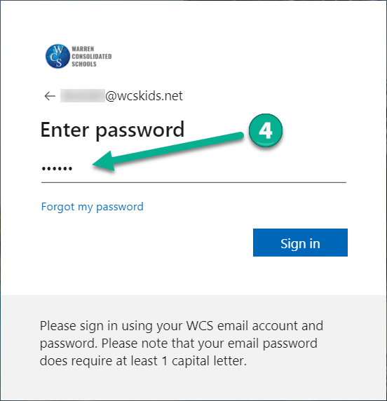

- This will take you to your Office 365 dashboard. This dashboard contains many useful programs available to WCS students, including Outlook (email). In the upper left corner, select the “App Launcher” sometimes referred to as the “Waffle.” 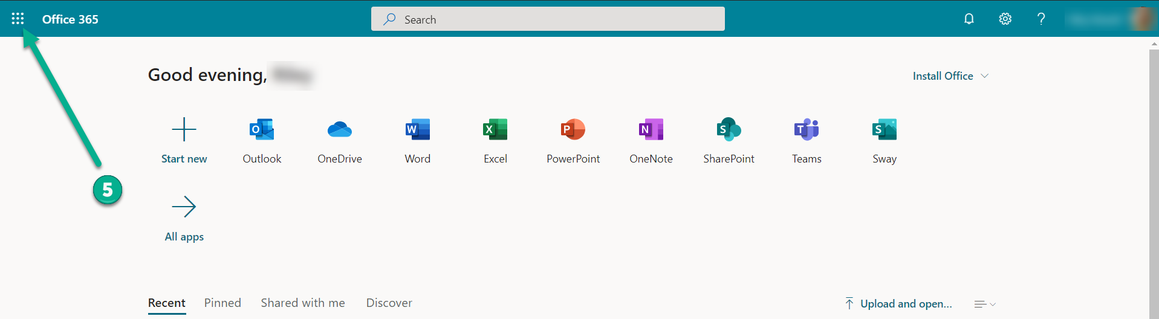

- Select “All Apps.”
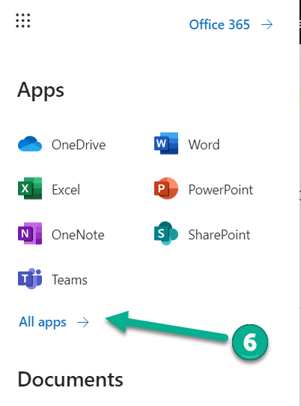
- Then select the Schoology icon. After the initial login, you will no longer need to go to “All Apps.” Schoology Icon will appear on the “App Launcher” (refer to step 5). 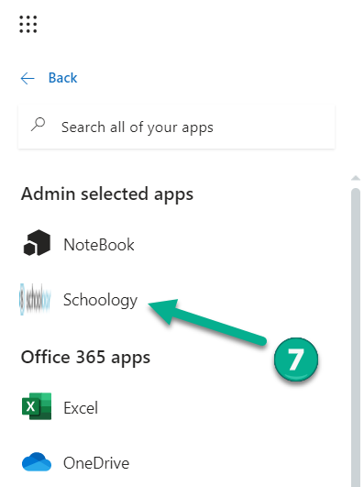
This will take you to your Schoology Dashboard. From the dashboard you can:
- Enter a “Course”
- View “Recent Activity”
- Check to see if you have any “Notifications”
- Send or Receive “Messages”
- Look at “Calendar” to see upcoming events
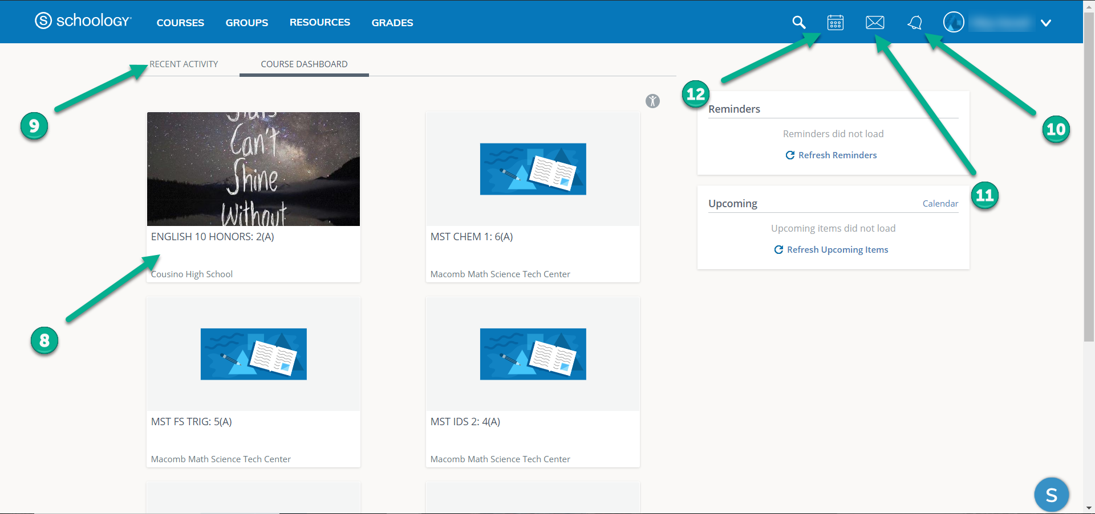

If a student recieves support services (ex. Resources Room, ELL, Title I), an additional (7th ) class will be on the Course Dashboard.

Forgot your password?

Go to https://www.wcs.k12.mi.us/documentdepot/se/forms/27/Lookup.aspx and fill in the following fields:

- Student ID # - 6 digits.
- Your house number – just the numbers of your home address.
- Student Date of Birth – must be in mm/dd/yyyy format (ex.12/31/2020).

